
National University of Sciences & Technology (NUST) Balochistan Campus (NBC),
Department of Computer Science
Department of Computer Science
CS-250: Data Structure and Algorithms
Class: BSCS 3rd
Lab 6: Implmentation of Queues in different problems
Date: 30th October, 2024
Time: 10 am - 1 pm
Instructor: Dr. Adnan idrees
Lab engr: Safder Ali

NAME | Sameer Talreja
CMS ID | 457795

CS250: Data Structures and Algorithms Page 1

National University of Sciences & Technology (NUST)
Balochistan Campus (NBC),
Department of Computer Science
Lab 6: Implmentation of Queues in different problems
Introduction
This lab is based on queues and its implementation statically and dynamically.
Objectives
Objective of this lab is to get familiar with the queues and implement it in a programming language
Tools/Software Requirement
Visual Studio 2012 or gcc or g++
Helping Material
Lecture slides, text book
Description
In computer science, a queue is a particular kind of abstract data type or collection in which the entities in the collection are kept in order and the principal (or only) operations on the collection are the addition of entities to the rear terminal position and removal of entities from the front terminal position. This makes the queue a First-In-First-Out (FIFO) data structure.
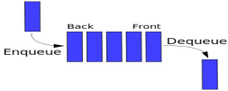
CS250: Data Structures and Algorithms Page 2

National University of Sciences & Technology (NUST) Balochistan Campus (NBC),
Department of Computer Science
The following sets of operation are generally supported by queue:
1. void Enqueue(element) – add an element at the rear end of the queue
2. element Dequeue() – removes and display the element from the front end of the queue 3. bool isEmpty() – checks if the queue is empty or not
4. bool isFull() – checks if the queue is full or not
5. void Clear() – release the memory allocated by queue
6. void FirstElement() – display the contents of first element of queue at front location
Lab Tasks
You have to implement a waiting room management system in an emergency ward of a hospital. Your program will assign an Id number to a patient in a first come first serve basis. The lower the id, the sooner the service will be provided to the patient.
Your program will contain the following methods:
RegisterPatient(): This method assigns an Id (which is auto-generated) to a patient and register him/her to the system.
ServePatient(): This method calls a patient to provide hospital service to him/her.
CancelAll(): This method cancels all appointments of the patients so that the doctor can go to lunch.
CanDoctorGoHome(): This method returns true if no one is waiting, otherwise, returns false.
ShowAllPatient(): This method shows all ids of the waiting patients in SORTED order. (Hint: use the sorting methods learnt in class using the appropriate data-structure for each task) [Sorted according to their names]
Solve the above problem using an array based queue.
Important Note: Practice your knowledge of OOP with C++ when creating a solution.
CS250: Data Structures and Algorithms Page 3

National University of Sciences & Technology (NUST) Balochistan Campus (NBC),
Department of Computer Science
Solution:
Solution
Task 1 Code:
#include <iostream>
using namespace std;
# define maxsize 50
class hospital{
int * arr;
int front;
int back;

public:
hospital(){
arr=new int[maxsize];
front=0;
back=-1;
}

void Register_patient(int &id){
if(back==maxsize-1){
cout<<"No appointments to give"<<endl;
return;
}
arr[++back]=id++;
}
void serve_patient(){
if(front>back){
cout<<"No patients to serve"<<endl;
return;
}
cout<<"Serving patient id : "<<arr[front++]<<endl;
}

void clear_all(){
front = 0;
back =-1;
}

void can_doctor_go_home(){
if(front==0||front>back){
cout<<"Doctor can go home "<<endl;
return;
}
cout<<"Patients are waiting Doctor can't go home"<<endl;

}

void show_all_Patients(){
if(front>back){
cout<<"No patients to show "<<endl;
return;
}
cout<<"Patients to serve are : ";
for(int i=front;i<back;i++){

cout<<arr[i]<<" , ";
}
cout<<endl;
}

};
int main(){
hospital obj;
int nextid=01;
obj.Register_patient(nextid);
obj.Register_patient(nextid);
obj.Register_patient(nextid);
obj.Register_patient(nextid);
obj.show_all_Patients();

obj.serve_patient();
obj.serve_patient();

obj.can_doctor_go_home();
obj.clear_all();

}

Task 1 Output Screenshot:
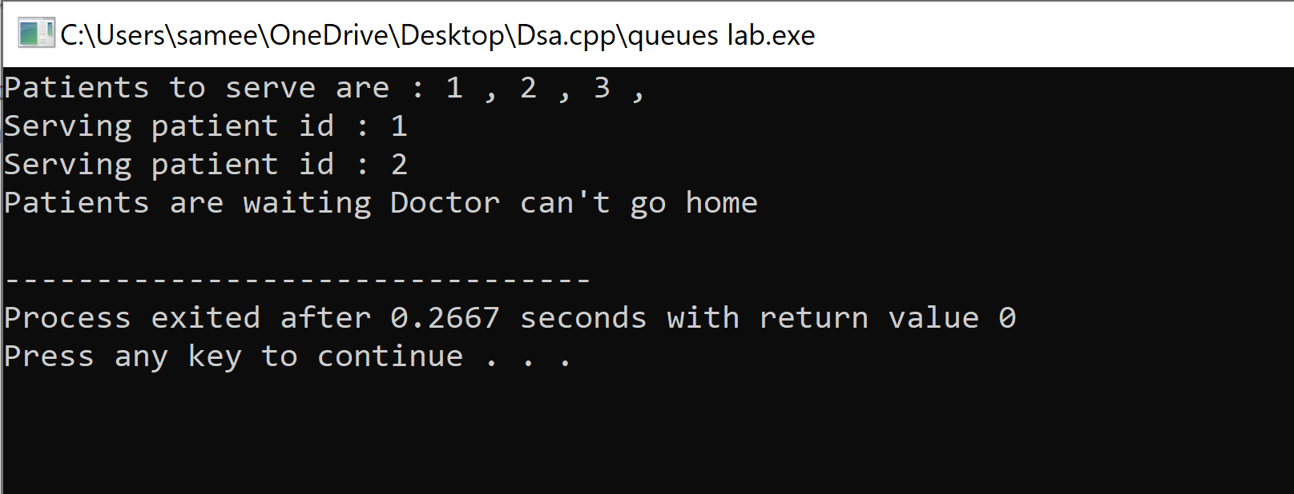

Deliverables
Compile a single word document by filling in the solution part and submit this Word file on LMS/ google classroom. This lab grading policy is as follows: The lab is graded between 0 to 10 marks. The submitted solution can get a maximum of 5 marks. At the end of each lab or in the next lab, there will be a viva related to the tasks. The viva has a weightage of 5 marks. Insert the solution/answer in this document. You must show the implementation of the tasks in the designing tool, along with your complete Word document to get your work graded. You must also submit this Word document on the LMS/google classroom. In case of any problems with submissions on LMS, submit your Lab assignments by emailing it to Mr. Safder ali. students.em96@gmail.com
CS250: Data Structures and Algorithms Page 4

